COHRED Statement 2007

Are international health research programmes doing enough to develop research systems and skills
in low and middle income countries?

Responsible Vertical Programming:
How global health research can deliver essential research, achieve impact and build national systems

Council on Health Research for Development (COHRED)
The COHRED Statement highlights important issues in health research for development.

Health research is a key instrument to reduce poverty and improve health across the globe. The way in which research is done and the questions it addresses make an essential difference between health research that is a tool to deliver technical solutions to those who can afford them; or health research as central element of alleviating human suffering, improving health and health equity, and making development activities sustainable.

COHRED Statements are issued whenever there is a need to examine and emphasize issues in ‘research for health’ that make research work … for everyone. COHRED Statements are prepared by COHRED and in partnership with other organisations if this helps advance solutions to the issues raised.

COHRED encourages feedback, debate and the sharing of experiences on the concepts presented in this report.
Please respond to rvp@cohred.org

For more information and resources on responsible vertical programming for health research:
www.cohred.org/HealthResearchWeb
www.cohred.org/rvp

Contributions
This paper is a collaborative effort of COHRED staff and Board, and shared vision based on extensive experience working with research systems in low and middle income countries. It was drafted by Carel IJsselmuiden and Andrew Kennedy with significant inputs from Sylvia de Haan, Martine Berger, Michael Devlin and the work of Sandrine Lo Iacono.

© Copyright Council on Health Research for Development (COHRED) 2007 ISBN 92-9226-024-3
COHRED statement 2007

Responsible Vertical Programming in health research

Research plays a crucial role in developing solutions to the health problems suffered by the populations of low and middle income countries. Most health research for and in low and middle income countries is funded from external sources. And most of this externally funded research takes the form of ‘vertical’ – condition – specific – programmes.

As a result…
- The health research agenda in poor countries is mostly determined from the outside, not based on national health research priorities, and concerns only those conditions for which international funding is available – largely HIV/AIDS, TB and malaria.
- Externally funded research is not primarily concerned with leaving behind sustainable national research and research governance capacity – most capacity that is built focuses only on those competencies needed for individual research projects.
- An important opportunity for sustainable socio-economic development is missed, if health research does not become a driver for development in low income countries, where external investments in health research constitute a large part of total investments in science and technology.
- Research programmes rarely make provision to translate research findings into action – leaving this to under-funded, fragile health systems.

Responsible Vertical Programming in health research
- Vertical research programmes can be highly effective at increasing research production and developing new interventions for neglected conditions that have the potential to improve the lives of millions of people. However, the ways these programmes are managed can make the difference between research as a technical effort with dubious implementation potential and research as a catalyst for development – that achieves its potential to improve people's lives.
- A vertical research programme is responsible if succeeds in building the capacity of a country’s researchers and the national research system – in the process of achieving its own research goals.

What can be done?
- Countries have to take responsibility to put in place and resource a basic national health research system. At the least, they should provide mechanisms for research governance that can guide, negotiate, contract, prioritise, manage, follow-up on research and translate it into action.
- External research programmes and sponsors working for the health of people in low and middle income countries should realise that their research cannot be done in isolation from the context of poverty and under-development. Their response to this should be to invest in good partnership building that leaves behind substantial individual and institutional capacity when the programme is completed. This also means helping strengthen national research systems and governance.

What is the problem?

Research and innovation are essential drivers of the development of any modern economy. Health research is a core component of this, and is crucial to solving specific health problems and optimising health system performance. Stated otherwise: there are few, if any, modern nations that have developed without investing substantially in scientific research and innovation – either directly or indirectly. This is the scenario for high income countries and those making the transition from ‘low and middle’ to ‘high’ income, including China, India, Brazil, Mexico, the Philippines, Thailand, Malaysia,1 South Korea,² South Africa, Tunisia and others.
The situation in many low and middle income countries is different. Investments in research and innovation are minimal, and are often considered luxuries that follow development rather than being core drivers of development. Health research is no exception. Most low income countries do not invest sufficiently of their own resources in health research to address local needs. As a result, most health research “relevant” to low and middle income countries is done for them – sometimes with them – but rarely by them. This approach to research is done in a ‘vertical’ manner – meaning that it focuses only on conditions for which the international community makes funds available; and without necessarily strengthening the national health research system.
Even research done in and with low and middle income countries is driven by international health research priorities rather than the ‘national agenda’. So it is largely the international agenda that determines how scarce research resources in low income countries are allocated and the research questions addressed. In many low income countries, externally funded health research is the only investment in scientific research and innovation. The result is that crucial opportunities to support creative environments conducive to research, innovation and progress are lost if health research in low and middle income countries is not embedded in national research system development.
Vertical research programmes can take a number of different forms, either as collaborations of multilateral agencies (e.g. the UNICEF, UNDP, World Bank, WHO Special Programme on Research and Training in Tropical Diseases - TDR); centres of excellence (e.g. the International Centre for Diarrhoeal Disease Research Bangladesh - ICDDR,B); funding schemes of research councils, foundations or development agencies (e.g. the Grand Challenges for Global Health programme of the Bill and Melinda Gates Foundation); or public private partnerships (e.g. the International Aids Vaccine Initiative - IAVI).

Box
Responsible Vertical Programming: what is the problem?
  - Health research needed by developing countries is mostly conducted for them, sometimes with them but rarely by them
  - Health research in developing countries is problem-specific – or ‘vertical’ and does not usually contribute to building the national system for health research
  - The questions addressed by health research in developing countries are largely determined by the international community – specifically those funding ‘global health research’
  - Health research is not seen as a key driver of development in low income countries – and this constitutes a missed opportunity towards real and sustainable progress

Health research and the Millennium Development Goals
In 2001, the Commission on Macroeconomics in Health proposed that the international community’s research funding for ‘diseases of the poor’ should be substantially increased to US$3 billion per year by 2007.³ It was recommended that this funding be split evenly between investments in new intervention development, by international research programmes, and priority research needed by the health systems in Low and Middle Income Countries (LMICs). While investments in vertical programmes are clearly increasing, investments in public sector health research in many LMICs are stagnating.⁴ Health research is not fulfilling its potential role in improving health in these countries. This is because little research is being produced that can be used by practitioners, managers and policy makers to inform health sector decision making.⁵⁻⁷ Health research performance failure may be one reason why many LMICs are unlikely to achieve the health-related Millennium Development Goals. In addition, research in LMICs does not address disease burdens associated with conditions not traditionally perceived as their priorities – such as mental health, injuries and non-communicable diseases.

Dependency on foreign funds
Few LMICs invest sufficient amounts of their own resources in health research,4 even though many African countries re-committed themselves to increase expenditure on health research in 2006.8 Most countries rely on foreign partners for research project funds and these partners usually commission research as disease or condition specific – or vertical – programmes. For example, between 1991 and 2000, 100% of health research project funds in Tanzania came from foreign sources.⁹ Uganda does not provide any project funding for health research,¹⁰ while external health research project income totals some $24 million.¹¹ This leads to the situation where national research production in many low and middle income countries addresses only a few high profile health conditions – those for which funding is available – neglecting other major national priorities that can benefit from research.
Health research production in low income countries is heavily skewed towards six conditions: HIV/AIDS, malaria, diarrhoeal diseases, tuberculosis, maternal conditions and tropical diseases.¹³ These conditions, which are all beneficiaries of major international vertical research programmes, make up 31% of the overall disease burden for low income countries – but more than 80% of their research output – leaving many important problems under-researched (see Figure 1).

Table 1
Research funding for health research institutions in Tanzania 1991-2000

Source of funds | Type of funding | US$ millions (%)
Domestic | Infrastructure | 414 (88)
Foreign | Infrastructure | 5 (1)
Domestic | Research projects | -
Foreign | Research projects | 49 (10)
Total |  | 468
Source: adapted from Kitua 2002.⁹

Current donor interest in low income countries is focused on a limited number of conditions, which means that the health research funds today are mainly for TB, malaria and HIV.
Synthesis of stakeholder interviews - Zambia¹²

Different research priorities
‘Vertical’ research programmes can play an important role in reducing morbidity and mortality for diseases that affect millions of poor people. They are effective strategies for the development of new products¹⁴ and for stimulating research on neglected diseases.¹³ At the same time, the evidence produced by such programmes may be of little use to those faced with the challenge of improving their population’s health. ‘Vertical’ research programmes align their activities with their own objectives and not necessarily with the research priorities of the countries in which research is done. The overwhelming focus is on generating new knowledge and developing new interventions even though this research is unlikely to contribute to improving health within the next ten years. For example, in the HIV/AIDS field commentators are speculating that “a vaccine to prevent HIV infection will not be found for, at the very least, several decades to come – if at all”.¹⁵
Research that can make a real difference to the health of people living in low and middle income countries in the short and medium term must address more applied topics. For example, in a large-scale consultation in South Africa to identify research priorities required to achieve the Millennium Development Goal on child mortality, nine of the top ten priorities addressed health systems and policy research. Only one called for the development of a new intervention.¹⁶

FIGURE 1
Dependence on project funding from foreign sources leads to research production that addresses just a few high-profile conditions, all priorities of the international research community, leaving many major problems seriously under-researched¹³

Governance and Management – who decides?
Vertical programmes often bypass the governance and management structures of countries. For example, in Cameroon, 25% of all health research expenditures in 1999 was contracted directly to individual researchers, bypassing government and institutional systems of governance.¹⁷ In Zambia, only 12 health research projects were registered with the national Council of Science and Technology in 2006,¹² a small fraction of the projects undertaken in the country. In South Africa, as in many other countries, there is no national register of externally funded research. Even where this information is available – it often covers clinical trials only.
Vertical research programmes are accountable to oversight by their home institutions and sponsors; but usually not to that of the countries where the research activities are conducted. This lack of local accountability weakens national research systems and governance. In these situations, national decision makers are largely unaware of the research done in their country. Faced with this situation, countries cannot provide direction to their national systems of health research, manage and develop them effectively or act on the research findings.

The ‘health research funding paradox’
In low and middle income countries that do invest in health research, the costs of maintaining a core group of trained scientists and basic research facilities is carried by national governments. In Tanzania, for example, of the total funds for health research allocated to supporting the country’s institutional infrastructure – mostly salaries and facilities – only 1% came from foreign sources (See Table 1).⁹ Because vertical research programmes are able to fund project costs – to purchase consumables and the latest high-cost, high-tech equipment and pay for other research essentials such as additional staff and vehicles, it is largely this external funding that determines what research is done – by those whose positions and offices are paid for by national governments in low and middle income countries. Vertical research programmes therefore benefit from the support of LMICs to achieve their research goals, without investing in the infrastructure that enables this to happen.
Research funding often only covers direct project costs (such as staff time or project equipment) ignoring indirect costs (e.g. facilities and administration), forcing institutions to subsidise these expenses. For example, the University of Cape Town estimates that indirect project costs constitute 43% of research costs. However, between 2002 and 2005, the university was able to recover just 6% of indirect costs from project sponsors.¹⁸ The US National Institutes of Health allow only 8% of indirect costs for foreign institutions receiving their funds.¹⁹ It pays many times this – up to 100% in some cases – to US institutions.²⁰
This problem does not only arise at the institutional level. If anything, it is even worse at the level of the national research system. Virtually no international research programmes make provisions – either financial or technical – to help sustain the national system that enables the research they fund to take place. Small fees for local research ethics review or for registration of research projects with national councils may sometimes be paid. But no externally-funded research programmes include capacity building for government research managers, research priority setting, or for national research policy development. All of this has to be funded from national budgets.

The ‘health research funding paradox’
Many low and middle income countries contribute more to the overall budget for research in their countries than they receive from external sources. Yet is the external contributions that often decide what research questions are being addressed.

Narrow focus of the research programmes –
operating in isolation from national health research systems
To ensure high quality research, vertical programmes often have to build local research skills and competence. Ideally, this research capacity should be built in a generic manner so that it can be used to address health problems in addition to those on which the vertical programme is focused. For example, skills built through epidemiology training needed for phase II or III clinical trials should also be applicable to research on environmental health, health sector quality control, or childhood disability.
In a well-integrated system these skills could be used to enhance research in related fields. But in reality, these opportunities are not realised when research is done in a project-specific manner. For example, in Bangladesh, which hosts the International Centre for Diarrhoeal Disease Research (ICDDR,B), 52% of the country's research outputs between 1999 and 2001 addressed diarrhoeal disease; but this excellence produced little research addressing the other major conditions contributing to the country’s disease burden (see Figure 2).

FIGURE 2
Vertical research programmes can have little impact on strengthening research production outside of their focus area¹³

Achieving impact
For interventions developed by vertical research programmes to achieve their potential in improving population health, effective health systems to deliver the intervention are required. Health research systems are also needed, to adapt the intervention to local contexts, evaluate effective modes of service delivery and inform national policies to facilitate uptake of. There are many cases of the under-utilisation of known effective interventions.^{6,21} A prime example is the Haemophilus influenzae type b (Hib) vaccine, developed in the early 1980s – but still to achieve its potential impact.²² To ensure that research results are communicated and used – i.e. achieve impact – strong national health research systems with a broad range of skills and expertise are needed. This includes strong links to health systems to deliver the interventions and ensure their uptake. While this fact is widely recognised in debate and literature, virtually no international research programmes make provision for links between research and action.

Good research needs good research systems … and these require funds

Responsible Vertical Programming (RVP)

Toward research for development

Surely, for low and middle income countries, the ultimate objective of health research is to improve health and development to the point where the country is no longer dependent on external assistance. Viewed from this perspective, all interventions addressing specific problems in low and middle income countries should be supportive of achieving this objective. The requirement to align with long-term development goals is the one factor essential to national development,²³ just as staff of successful companies align with the corporate mission.²⁴
A vertical research programme is responsible if it succeeds in building the capacity of a country’s researchers and the national research system – in the process of achieving its own research goals.

Implications for low and middle income countries

Research system building
It is unreasonable to expect that individual research projects or even large-scale programmes can alone achieve major development goals beyond those required for the research. Researchers do not necessarily have development expertise. Research sponsors are unlikely to fund additional expenditures. And governments may consider the widening of the scope of research programmes as interference in legitimate political processes.
To encourage research programmes to have a more long term impact beyond their immediate objectives, low and middle income countries should put in place a national health research system (NHRS).
As the world map shows low and middle income countries are progressively recognising the need to strengthen their national health research systems and are establishing formal structures to direct and manage their research efforts, better understand what their research needs are, and identify how their systems can be strengthened to achieve these aims.
With these foundations in place, countries are in a stronger position to negotiate with international research programmes, to ensure that national goals are addressed in research projects and that strengthening of the national health research system is built into collaborative agreements.

Political support
The allocation of national funds to research strengthening is an important step in research system development and strong political support is essential to achieving this. Especially in Africa, national governments do not sufficiently invest their own resources in health research governance and research projects, often relying exclusively on external support for health research. As political support for health research is serious only if it translates into research budgets, it is essential that – at the least – governments start paying for the governance of research. This will ensure that external research funding can become more relevant to national priorities and health objectives as well as to international ones.
Increasingly, low income countries are making explicit investments in research. For example, Rwanda has made a number of high profile statements of its commitment to science and technology (S&T)-driven development, with aims to invest 3% of GDP by 2010.³⁹ These statements have been put into action with the establishment of a governance and regulatory framework for S&T and the allocation of 1.7% of GDP in 2006. This has enabled Rwanda to negotiate considerable co-investments from the World and African Development Banks, helping the government on its way to the 3% target.

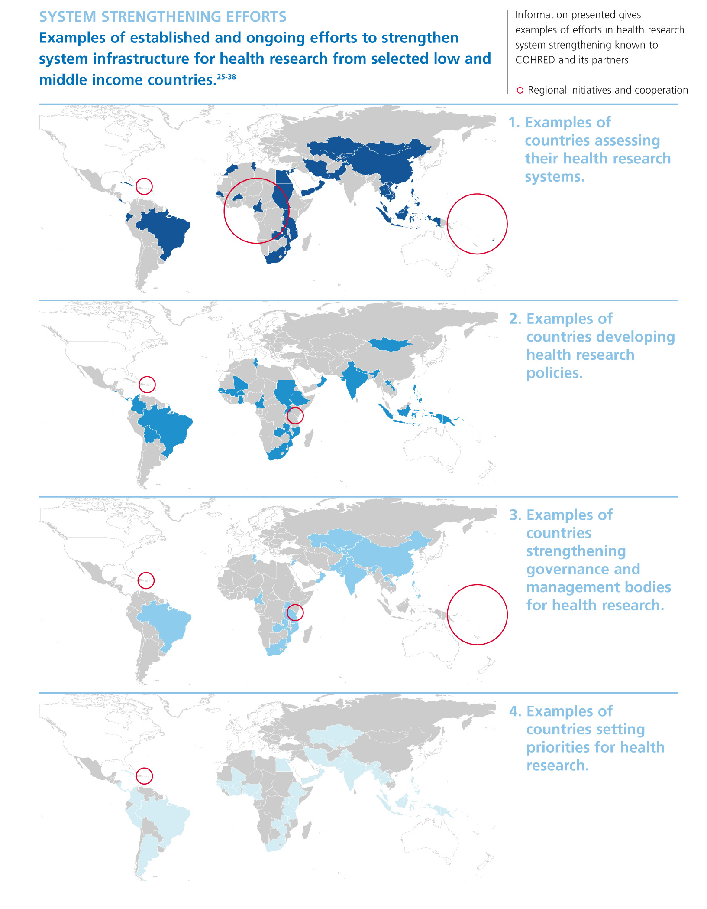
Governance of health research
A basic research governance infrastructure increases a country’s ability to link short-term research objectives with longer term health and development aims. The group of ‘innovative developing countries’ – India, Brazil, South Africa and others – have come a long way to putting in place national governance that enables them to adopt stronger positions on international research relationships that affect their populations.
A regional example is telling. In June 2007, the Organisation for Economic Co-operation and Development - Development Assistance Committee (OECD-DAC) convened a ‘high-level forum’ to stimulate more research and development on medicines for neglected and infectious diseases.⁴⁰ The essence of the meeting was to understand how to provide incentives for the pharmaceutical industry in OECD countries, to increase their research efforts on drugs for these diseases. However, the forum did not consider the complementary agenda of: how to provide incentives for technology transfer for drug R&D and drug regulation so that – in the long term – more of the R&D capacity will be located in the countries where these diseases occur. Such an agenda is more likely to lead to sustainable development as it will reflect not only on incentives for industry, but also on how LMICs should strengthen their innovation and production systems to make technology transfer – south-south as well as north-south attractive – or even possible. During this OECD meeting, the Minister of Public Health of Cameroon offered to host such a complementary agenda meeting – to ensure that the initiative is conducted with southern countries and not just for them.⁴¹

“It is becoming clear that strong political will and commitment is creating change. For example the efforts of some African countries last year [2006] in Abuja and Accra have permitted a clearly articulated African position on the role that the WHO Tropical Disease Research programme should play”. Dr Urbain Olanguena Awono, former Minister of Public Health, Cameroon

Implications for researchers, research sponsors, research programmes
Research is not done in a vacuum. An essential basis for responsible vertical programming is the recognition that the development of low and middle income countries is part of the context in which international health research programmes operate.
While it is unrealistic for countries to expect that health research programmes will solve major developmental problems, it is equally unreasonable for health research programmes (including the researchers, their institutions and sponsors) to expect that low and middle income countries have all the resources they need to manage research prioritisation, governance and translation of research into action. The fact that global health research is needed to solve essential health problems in low and middle income countries in the first place is indicative of the need for research system support.
In this light, managing research programmes in isolation of the context and systems in which it occurs is not optimal. The ‘urgency of research’ argument – namely, that building systems will take too long and that new interventions are needed now – is rarely a justification, as intervention research rarely leads to rapid answers.^{15,42} Even when solutions are developed, there are long lag times before implementation in low and middle income countries is achieved.^{43,44} ‘Urgency’ itself cannot, then, be the rationale to ignore national systems and countries’ development needs when doing international health research.
In reality, isolating research from development is based on researcher imperatives (careers and publications) and on limitations imposed by research sponsors (funding can only be used for projects – rarely for institution building – let alone system building). While many of the principal investigators of international research programmes in low and middle income countries will acknowledge system weaknesses, this does not mean that they will be explicitly addressed in research protocols.
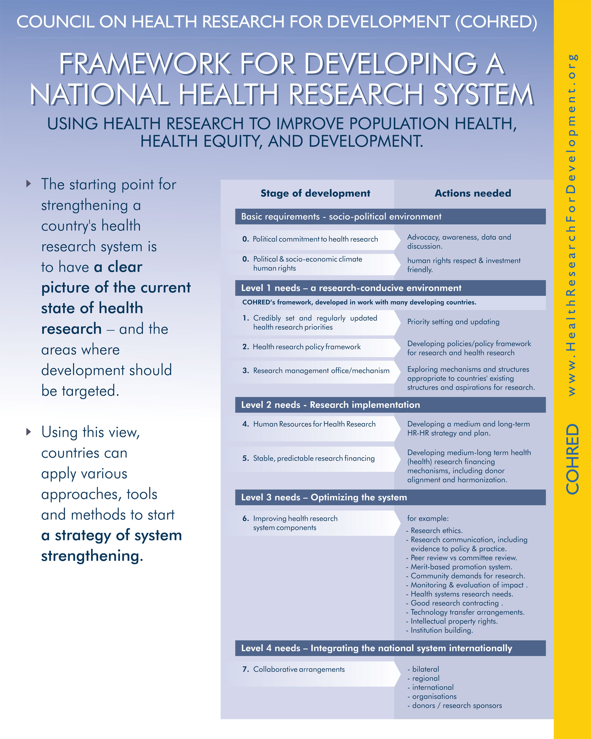
Yet, how research programmes are conducted can have important positive effects on sustainable research capacity in countries. Good research partnerships are a solid beginning to optimise the potential impact of research beyond the immediate project outputs, and there are strong examples of how this can be done. These include the ENRECA programme supported by Denmark (ENhancement of REsearch CApacity in developing countries)45 and the Swiss supported KFPE programme (Commission for Research Partnerships with Developing Countries).⁴⁶ But good partnerships are not sufficient, and more needs to be done. In consultations for its new 10 year strategy the UNICEF, UNDP, World Bank, WHO Special Programme on Research and Training in Tropical Diseases (TDR) has acknowledged some of the issues required for it to extend the ‘responsibility’ of its programme, pledging to: “Empower scientists and institutions from disease endemic countries. This moves beyond traditional research training to build leadership at the individual, institutional and national levels so that disease endemic countries can better initiate research activities and develop a stronger presence in international health research”.⁴⁷
Governance of research
In the absence of functional research governance in countries, it is difficult to optimise the benefits of health research. For that reason, international research programmes should support the strengthening of national research governance capacity where this is found to be weak. While this is generally accepted practice in terms of building local research ethics review capacity, it is not applied to national research governance. Using a framework for developing national health research systems governance (see page 16), research programmes can assess where to best support research systems to increase national capacity, autonomy and sustainability – and achieve this as a part of the investments made to conduct research programmes.
Board and committee representation is another important aspect of research governance. Most large research programmes have boards, and some of these have strong developing country representation. But most remain dominated by northern interests whose focus is more likely to be on programme goals rather than on the longer term development impact of research.
Finally, if research governance includes more national representation on research programme ‘advisory committees’, this may well serve to emphasise the developmental aspects of health research.

System and institution building
For many years, Sweden’s international development assistance for research has focused on developing research institutions in LMICs.⁴⁹ Other research sponsors, for example the Wellcome Trust, have – after a long history of supporting capacity development at the individual level – seen the need to complement this individual capacity building with activities that build the capacity of institutions.⁵⁰
The crucial part in these initiatives is that they provide support comprehensively – as part of systems or of institutions. Programmes that have aimed at building only the system components that they require to achieve their aims, may find that results are often not what they anticipated. Without a governance and management infrastructure, the parts of the system that were ‘strengthened’ may remain under-used, unsustainable – or both. For example, interviews with 38 senior stakeholders in Trinidad and Tobago – which has no formal governance and management framework for health research – found that they were unaware that the country had a national research ethics committee.²⁸

Achieving impact – seeking complementarity
Taking a Responsible Vertical Programming perspective, the question, then, is: can research programmes support national research capacity building in a sustainable manner without detracting from research outputs, substantially increasing costs or causing delay in the effective delivery of health interventions? The answer to this question is almost always yes. It is not additional resources that make research ‘responsible’ – but the way in which research is done.
There are many good case studies – such as the ICDDR,B’s life cycle approach to research prioritisation that covers biomedical, socio-behavioural and health systems research to ensure that it has maximum impact on population health.⁵¹ Yet, this is hardly sufficient to optimise the developmental potential of health research.
Research for research outputs and Research for development are complementary – not contradictory – approaches to development. As in any business, the realisation of the overall goal is dependent on identifying ‘strategic partners’ – whose core competencies and abilities are both complementary and essential for success. Understanding the context in which the research programme is done, understanding the potentials and limitations of one’s own research effort, and seeking others who can engage in complementary activities are the three steps to making health research work (specific steps and approaches are listed on page 7 and 9).
Alignment with national research system priorities and harmonisation^{52,53} between the many research sponsors and agencies are but two aspects that need to be considered by any substantive research programme conducted in low and middle income countries.ª

Table 2
Representation from low and middle income countries on governance bodies of selected vertical programmes

Programme | Number of board members from LMICs / Total number of board members
Aeras, Global TB Vaccine Foundation | 2/11
Africa Malaria Partnership - AMP | -/-*
Alliance for Microbicide Development | 0/7
Drugs for Neglected Diseases Initiative - DNDi | 5/11
European Malaria Vaccine Initiative - EMVI | 1/8
Foundation for Innovative New Diagnostics - FIND | 0/4
Global Alliance for TB drug development - GATB | 3/13
Institute for OneWorld Health | 1/7
International Aids Vaccine Initiative - IAVI | 2/12
International Centre for Diarrhoeal Disease Research Bangladesh - ICDDR,B | 9/17
International Partnership for Microbicides | 4/10
Malaria Vaccine Initiative - MVI | -/-
Medicines for Malaria Venture - MMV | 2/8
Microbicide Development Programme | 7/16
Pediatric Dengue Vaccine Initiative - PDVI | 4/12
UNDP-UNFPA-WHO-World Bank Special Programme of Research Development and Research Training in Human Reproduction - HRP | 18/33
UNICEF, UNDP, World Bank, WHO Special Programme on Research and Training in Tropical Diseases - TDR | 17/34
* The AMP is an initiative of GlaxoSmithKline and has no specified governance body independent of the company.
 MVI is a project funded by the Bill and Melinda Gates Foundation and does not have a specified governance body. The board of directors of its host organisation PATH has six, of eleven, members from LMICs
Source: adapted from Harmer 2005.⁴⁵

Seeking complementarity is as simple as:
• Mapping the context to be addressed for research to become meaningful in health.
• Understanding what your project or programme can achieve.
• Seeking others to cover parts of the programme where you lack expertise.
NB. Having a functional national research governance infrastructure will greatly assist individual research programmes to identify complementarity.

a Health Research Web (http://www.cohred.org/HealthResearchWeb/) is a growing resource that makes national health research system information available to all who need it – including to those preparing for responsible vertical programming.
Who will benefit from Responsible Vertical Programming?

Responsible Vertical Programming benefits all stakeholders active in health research and ultimately, the people for whom research is being conducted:
- Low and middle income countries will benefit from research that addresses national needs; strengthens rather than weakens and fragments national systems; and creates sustainable capacity that can address national research priorities.
- Researchers and institutions will benefit from more effective national research governance structures that provide clarity, guidelines and informed decision making; and from being able to focus on their area of expertise – knowing that others are taking care of complementary actions.
- Research sponsors will benefit from the stronger research capacity available in countries, from greater use of interventions they help develop, and from a more transparent research process.
- Society will benefit from a more effective research system and more rapid access to new evidence-based services and interventions and the resulting reductions in morbidity and mortality.

“When I was appointed as health minister in Mozambique, I thought I would be minister of health; instead I was minister of health projects – funded by donor countries” Dr Pascaol Mocumbi, former Prime Minister and former Minister of Health, Mozambique

Endnote:
‘Vertical Programming’ is not limited to health research. Its complications are also felt in the wider health and development environment. In the health sector, the tensions between those promoting vertical programmes and those favouring system building to achieve health development have existed for more than 40 years.⁵⁴ After the successes of the smallpox eradication and onchocerciasis control programmes in the 1950s the debate moved toward favouring the ‘horizontal’ approach of “Health for All”, by 1978.⁵⁵ Since then, the pendulum has swung back to vertical approaches with the burgeoning of global health partnerships. These approaches are clearly complementary, but efforts to examine how ‘vertical’ and ‘system approaches’ can be used to greatest effect have been severely hampered by the quality and scarcity of evaluative studies.^{3,56}

Similar problems have been identified in the international development sector,⁵⁷ from which the Paris Declaration on Aid Effectiveness, 2005 has resulted. The Declaration aims to increase the impact of development assistance by facilitating the alignment of aid with national priorities, increasing harmonisation to reduce transaction costs, enhancing local ownership, focusing investments on results and fostering greater mutual accountability. All of these aims have strong parallels with enhancing the effectiveness of ‘vertical’ research programmes through Responsible Vertical Programming. While this paper does not explicitly address research sponsored by the private for-profit sector, the problems, arguments and solutions presented here apply equally to research done by commercial organisations.

References

- Watson R, Crawford M, Farley S. Strategic approaches to science and technology development. Policy Research Working Paper 3026. Washington: World Bank, 2003.
- Suh J, Aubert J-E, Anh D-G, Chen D. Korea as a knowledge economy: evolutionary process and lessons learned - overview. Washington: World Bank, 2006.
- Commission on Macroeconomics and Health. Macroeconomics and Health: Investing in health for economic development. Geneva: World Health Organization, 2001.
- Global Forum for Health Research. Monitoring Financial Flows for Health Research. Geneva: Global Forum for Health Research, 2006.
- Rochon P, Mashari A, Cohen A, Misra A, Laxer D, Streiner D, et al. Relation between randomized controlled trials published in leading general medical journals and the global burden of disease. CMAJ 2004;170:1673-7.
- World Health Organization. World Report on Knowledge for Better Health: Strengthening Health Systems. Geneva: World Health Organization, 2004.
- Mexico, 2004: global health needs a new research agenda. Lancet 2004;364:1555-6.
- Accra Communiqué. Health Research for Disease Control and Development; 2006; Accra.
- Kitua AY, Swai GBR, Urrio T. Fund Flows to Health Research Institutions in Tanzania. Dar es Salaam: Tanzania National Health Research Forum, 2002.
- COHRED. Donor alignment and harmonisation in relation to national health research priorities project: Uganda country report. Geneva: COHRED, in press.
- Uganda National Council for Science and Technology. Research registration status report for 2005. Kampala: UNCST, 2006.
- COHRED. Donor alignment and harmonisation in relation to national health research priorities project: Zambia country report. Geneva: COHRED, in press.
- Kennedy A, Glover S, Moreman B, IJsselmuiden C. Does the health research produced by low-income countries correspond with their health priorities? Submitted for publication.
- Moran M. A breakthrough in R&D for neglected diseases: New ways to get the drugs we need. PLoS Medicine 2005;2:e302.
- Horton R. AIDS: The elusive vaccine. New York Review of Books 2004;51(14).
- Tomlinson M, Chopra M, Sanders D, Bradshaw D, Hendricks M, Greenfield D, et al. Setting priorities in child health research investments for South Africa. PLoS Medicine 2007;4:e259.
- Mbanga G, Sama M. Tracking resource flows for health research and development in Cameroon. Geneva: COHRED, 2003.
- Wallace R. Introducing an effective research cost recovery system - UCT's experience. Southern African research & innovation management association annual meeting. Potchefstroom, 9-11 May 2007.
- Office of Extramural Research. Information for new grantee organizations. Bethesda: National Institutes of Health. [updated March 2007, accessed 19 November 2007] Available from: http://grants.nih.gov/grants/funding/welcomewagon.htm.
- Office of management and budget. Cost principles for educational institutions. Washington: Executive Office of the President of the United States. [updated 8 August 2000, accessed 22 November 2007] Available from: http://www.whitehouse.gov/omb/circulars/a021/a021.html.
- Haines A, Kuruvilla S, Borchert M. Bridging the implementation gap between knowledge and action for health. Bull World Health Organ 2004;82:724-732.
- Feikin D, Nelson C, Watt J, Mohsni E, Wenger J, Levine O. Rapid assessment tool for Haemophilus influenzae type b disease in developing countries. Emerging Infectious Diseases 2004;10:1270-6.
- Stiglitz J. Towards a New Paradigm for Development: Strategies, Policies, and Processes. Prebisch Lecture. Geneva: UNCTAD, 1998.
- Deming W. Out of the Crisis. Cambridge: MIT Press, 1989.
- World Health Organization Regional Office for the Eastern Mediterranean. A Study of National Health Research Systems in Selected Countries of the WHO Eastern Mediterranean Region. Cairo: WHO Regional Office for the Eastern Mediterranean, 2004.
- Guimaraes R, Pacheco Santos L, Angulo-Tuesta A, Jocob Serruya S. Defining and implementing a National Policy for Science, Technology and Innovation in Health: lessons from the Brazilian experience. Cadernos de Saude Publica 2006;22:1775-1794.
- Kirigia J, Wambebe C. Status of national health research systems in ten countries of the WHO African Region. BMC Health Serv Res 2006;6:135.
- Essential National Health Research Council of Trinidad and Tobago. Assessment of the National Health Research System of Trinidad and Tobago. Port of Spain: ENHR Council of Trinidad and Tobago, 2007.
- Ahmedov M, de Haan S, Sarymsokova B. Strengthening health research systems in Central Asia. Working paper 2. Geneva: COHRED, 2007.
- Pryor J, Morse Z, Prasad S, Koloi M, Kennedy A. National Health Research System Mapping in fifteen Pacific Island Countries. Nadi: Health Research Council of the Pacific, 2007.
- Anh L. National Health Research System Analysis in Vietnam. Global Forum for Health Research. Beijing, 29 October-2 November 2007.
- Burmaa B. National Health Research System in Mongolia. Global Forum for Health Research. Beijing, 29 October-2 November 2007.
- Chen J. A Health Research System Assessment in Shanghai. Global Forum for Health Research. Beijing, 29 October-2 November 2007.
- Opena M. Philippines National Health Research System Assessment. Global Forum for Health Research. Beijing, 29 October-2 November 2007.
- Kennedy A, Khoja T, Abou-Zeid A, Ghannem H, IJsselmuiden C. National Health Research System Mapping in Ten Eastern Mediterranean Countries. Eastern Mediterranean Health Journal (in press).
- Caribbean Health Research Council. Draft Regional Policy on Health Research Governance and Capacity Building in the Caribbean. Port of Spain: Caribbean Health Research Council, 2007.
- Health Research Web. Health Research Web: Information on national health research systems in low and middle income countries. Geneva: COHRED. [updated 10 October, accessed 19 November 2007] Available from: http://www.cohred.org/HealthResearchWeb/.
- WHO. Health Research Systems Analysis Initiative. Geneva: World Health Organization. [accessed 19 November 2007] Available from: http://www.who.int/rpc/health_research/en/.
- Kagame P. The importance of science and technology in Africa. Speech by H. E. Paul Kagame, President of the Republic of Rwanda. London: The Royal Society, 18 September 2006.
- High level forum on medicines for neglected and emerging infectious disease. Noordwijk Medicines Agenda; 2007 21 June; Noordwijk. OECD.
- COHRED. OECD High Level Forum Strengthening policies to improve availability of medicines for neglected and emerging infectious diseases. Research for Health Briefing 8. Geneva: COHRED, 2007.
- Berkley S. Don't give up on an AIDS vaccine. Los Angeles Times 2007 27 September. Available from: http://www.iavi.org/viewpage.cfm?aid=1859.
- Excler J-L. HIV preventive vaccines: myth and reality. Seminar 2002;520.
- IJsselmuiden C, Faden R. Informed consent and public health research in Africa: another look. N Engl J Med 1992;326:830-834.
- DANIDA. ENhancement of REsearch CApacity in developing countries. Copenhagen: DANIDA, 2000. [accessed 19 November 2007] Available from: http://www.um.dk/Publikationer/Danida/English/Evaluations/BilateralProgramme2000Volume2Annexes/anx_01/02_1_2.asp.
- Swiss Academy of Arts and Sciences. Commission for Research Partnerships with Developing Countries - KFPE. Berne: Swiss Academy of Arts and Sciences. [accessed 19 November 2007] Available from: www.kfpe.ch.
- UNICEF UNDP World Bank WHO Special Programme on Research and Training in Tropical Diseases. Ten year vision and strategy. Geneva: TDR, 2006.
- Harmer A. Global Health Partnership as New Players in the Global Health Arena: An International Relations Perspective. Antwerp: Institute of Tropical Medicine, 2005.
- SAREC. Policy for Research Co-operation. Stockholm: Swedish International Development Cooperation Agency, 2000.
- Wellcome Trust. Research Capacity Strengthening in Africa. London: Wellcome Trust, 2007. [accessed 19 November 2007] Available from: http://www.wellcome.ac.uk/doc_wtd028338.html.
- ICDDR,B. Strategic Plan to the year 2010. Dhaka: ICDDR,B, 2003.
- OECD-DAC. Paris Declaration on Aid Effectiveness. Paris: OECD, 2005. Available from: http://www.oecd.org/document/18/0,3343,en_2649_3236398_35401554_1_1_1_1,00.html.
- COHRED. AHA Study: donor alignment and harmonisation in health research. Geneva: COHRED. [accessed 19 November 2007] Available from: http://www.cohred.org/main/AHA_study.php.
- Mills A. Mass campaigns versus general health services: what have we leaned in 40 years about vertical versus horizontal approaches? Bulletin the World Health Organization 2005;83:315-6.
- Declaration of Alma-Ata. International Conference on Primary Health Care; 1978; Alma-Ata. WHO.
- Mills A. Vertical vs horizontal health programmes in Africa: idealism, pragmatism, resources and efficiency. Social Science and Medicine 1983;17:1971-81.
- World Bank. World Development Report 2004: Making Services Work for Poor People. New York: Oxford University Press, 2004.
Council on Health Research for Development (COHRED)

Board Members

Prof. Gopal Prasad Acharya
Chairman, Department of Medicine
Tribhuvan University Teaching Hospital, NEPAL

Prof. Abbas Bhuiya
Head, Poverty and Health Programme & Social and Behavioural Sciences Unit
International Diarrhoeal Disease Research Centre,
Bangladesh (ICDDR,B)
BANGLADESH

Prof. Jo Ivey Boufford
President of New York Academy
of Medicine
USA

Dr. Somsak Chunharas
Secretary General,
National Health Foundation
THAILAND

Dr. Don De Savigny
Head of Unit, Clinical & Intervention Epidemiology;
Public Health & Epidemiology
Swiss Tropical Institute
SWITZERLAND
Dr. Sambe Duale
Technical Director and Infectious
Disease Advisor,
Africa’s Health in 2010 project
DEMOCRATIC REPUBLIC OF CONGO/
USA

Ms. Annalize Fourie
Health & Education Advisor
Irish Aid,
SOUTH AFRICA

Prof. Carel IJsselmuiden
Director of COHRED
SOUTH AFRICA

Dr. Suzanne Jacob Serruya
Director of the Department of Science
and Technology
Science, Technology and Strategic Inputs Secretariat
Brazilian Ministry of Health
BRAZIL

Prof. Marian Jacobs
ChairCOHRED Board
Dean: Faculty of Health Science,
University of Cape Town
SOUTH AFRICA

Prof. Maksut Kulzhanov
Rector of Kazakhstan School of
Public Health
REPUBLIC OF KAZAKHSTAN

Dr. Daniel Mäusezahl
Senior Health Advisor Swiss Agency for Development & Cooperation (SDC)
SWITZERLAND

Prof. Stephen Matlin
Executive Director
Global Forum for Health Research
UK

Prof. Ernesto Medina
Center for Infectious Diseases,
Faculty of Medicine
National Autonomous University
of Nicaragua
NICARAGUA

Dr. Pascoal Mocumbi
High Representative, EDCTP -
European and Developing Countries Clinical Trials Partnership;
Former Prime Minister of Mozambique
MOZAMBIQUE

Dr. Delia Sanchez
Grupo de Estudios en Economia Organicatión y Políticas Sociales (GEOPS)
URUGUAY

Dr. Donald Simeon
Director, Caribbean Health Research Council
TRINIDAD & TOBAGO

Dr. Aissatou Toure Balde
Head, Laboratory of Parasite Immunology
Institut Pasteur Dakar
SENEGAL

Dr. Pem Namgyal
Medical Officer/Vaccine Preventable Diseases
WHO/South East Asia Regional Office
BUTHAN/INDIA
© Copyright and Fair Use
The Council on Health Research for Development (COHRED) holds the copyright to its publications and web pages but encourages duplication and dissemination of these materials for non-commercial purposes. Proper citation is requested and modification of these materials is prohibited. Permission to make digital or hard copies of part or all of this work for personal or classroom use is granted without fee and without a formal request provided that copies are not made or distributed for profit or commercial purposes and that copies bear this notice and
full citation on the first page. Copyright for components of publications that are not owned by COHRED must be honoured and permission pursued with the owner of the information. To copy otherwise, to republish, to post on servers, or to redistribute to lists, requires prior specific permission from COHRED.
COHRED is interested in tracking the use and effectiveness of its published information, and receiving feedback from readers. Readers interested in providing input or interacting with COHRED on its published materials please contact cohred@cohred.org

COHRED
Council on Health Research for Development
1-5 Route des Morillons
1211 Geneva, Switzerland
Tel + 41 22 591 89 00 - Fax + 41 22 591 89 10
E-mail: cohred@cohred.org
www.cohred.org

